ГУО «СРЕДНЯЯ ШКОЛА № 6 г. ЖОДИНО»
РАЗРАБОТАНО ДЛЯ СИСТЕМАТИЗАЦИИ ЛЕКСИКО-ГРАММАТИЧЕСКОГО МАТЕРИАЛА И ПОДГОТОВКИ УЧАЩИХСЯ 11 КЛАССОВ К СДАЧЕ ЦТ ПО АНГЛИЙСКОМУ ЯЗЫКУ

Коледа Светлана Михайловна,
учитель английского языка квалификационной категории «учитель-методист»

FORM 11
FIND MISTAKES
1. | 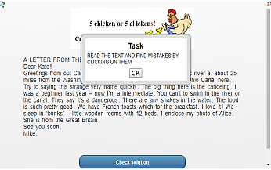 | https://learningapps.org/4580396
2. | 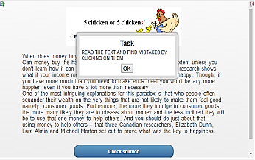 | https://learningapps.org/4619058
3. | 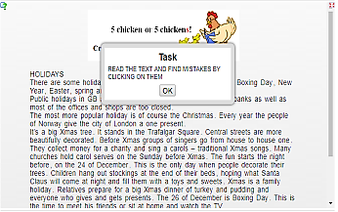 | https://learningapps.org/4619062
4. | 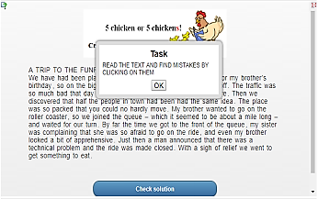 | https://learningapps.org/4622951
LET’S LEARN PHRASAL VERBS
5. | 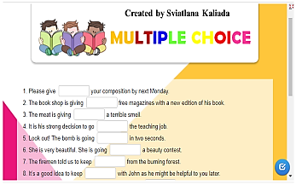 | https://learningapps.org/4512970
6. | 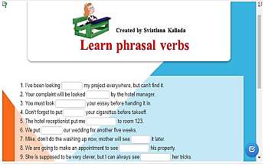 | https://learningapps.org/4505951
7. | 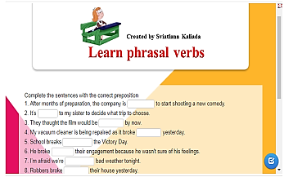 | https://learningapps.org/4505930
8. | 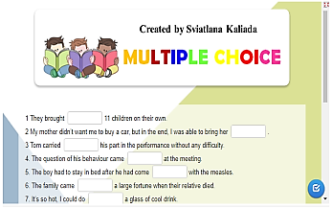 | https://learningapps.org/4513003
9. | 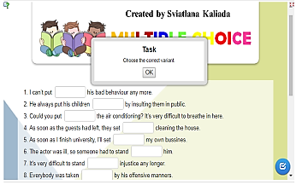 | https://learningapps.org/4513021
10. | 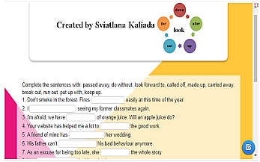 | https://learningapps.org/3524157
11. | 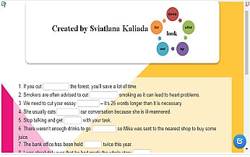 | https://learningapps.org/4519805
LET’S REVISE PREPOSITIONS
12. | 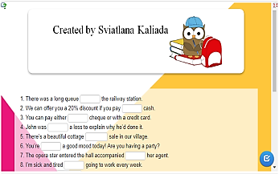 | https://learningapps.org/4513343
13. | 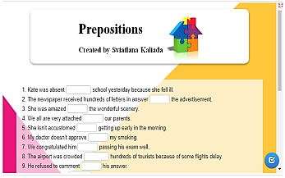 | https://learningapps.org/4517674
14. | 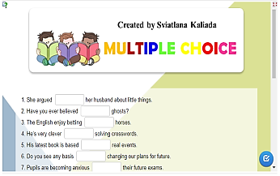 | https://learningapps.org/4519828
15. | 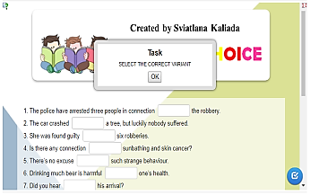 | https://learningapps.org/4519855
16. | 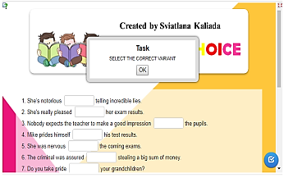 | https://learningapps.org/4519867
17. | 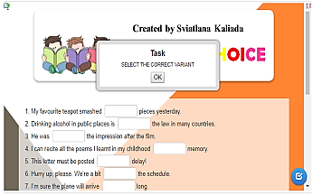 | https://learningapps.org/4519896
18. | 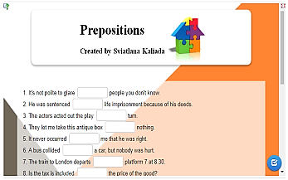 | https://learningapps.org/4521444
19. | 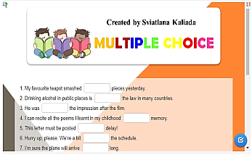 | https://learningapps.org/4519896
20. | 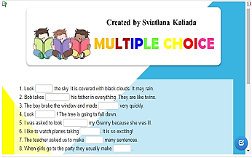 | https://learningapps.org/4521883
21. | 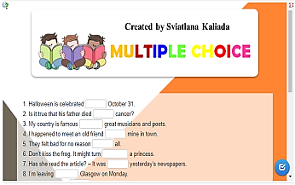 | https://learningapps.org/4635523
22. | 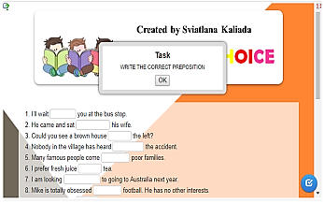 | https://learningapps.org/4642860
23. | 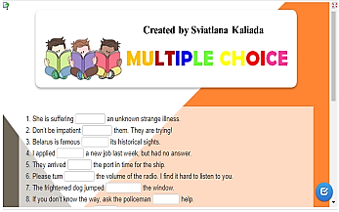 | https://learningapps.org/4642885
24. | 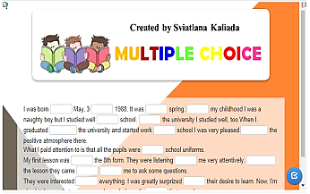 | https://learningapps.org/4658057
MULTIPLE CHOICE (GRAMMAR)
25. | 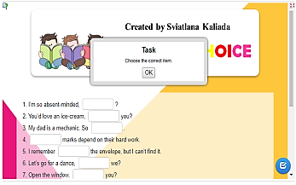 | https://learningapps.org/3501237
26. | 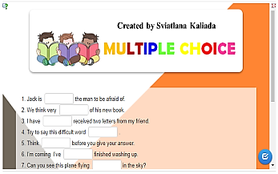 | https://learningapps.org/4522020
27. | 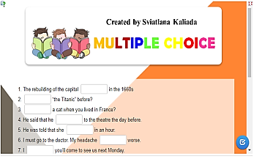 | https://learningapps.org/4527050
28. | 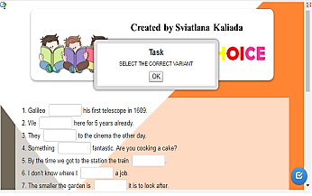 | https://learningapps.org/4527080
29. | 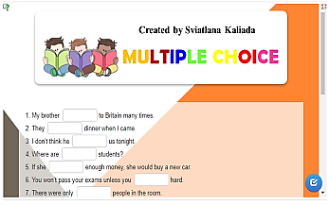 | https://learningapps.org/4533031
30. | 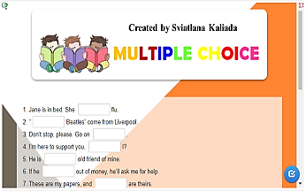 | https://learningapps.org/4536926
31. | 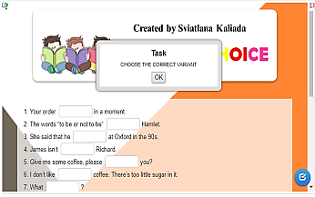 | https://learningapps.org/4536935
32. | 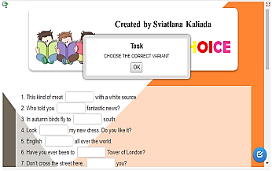 | https://learningapps.org/4580421
33. | 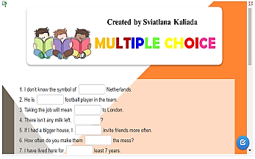 | https://learningapps.org/4585129
34. | 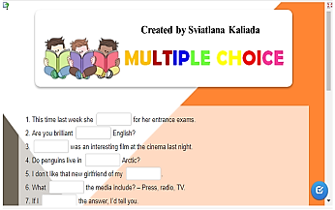 | https://learningapps.org/4599614

